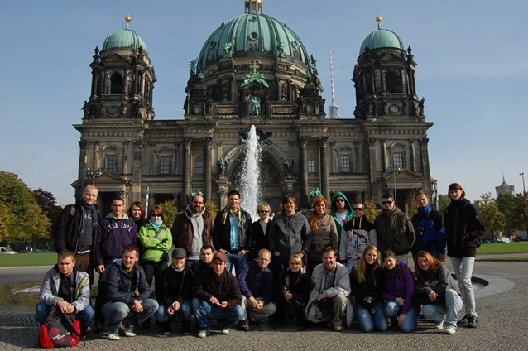
Bachelor study program: Investment planning in industrial enterprise
at the Slovak University of Technology in Bratislava
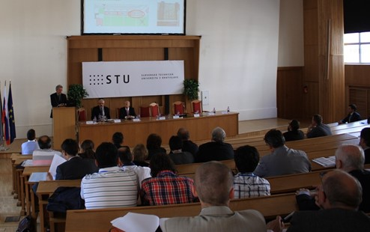
Would you like to study at the best technical university in Slovakia? Are you interested in technology and industry, but you can realize how to finance, plan and manage the production process? Just for You is a new and in Slovakia unique Bachelor study program Investment planning in industrial enterprise.
The effective functioning of industrial enterprise is not just a matter of technique and new technologies, but also a matter of rational planning, decision making about investments and financial transactions.
Study program:
Investment planning in industrial
enterprise
Form of study: full-time / 3 years
Academic degree conferred: Bc.
Application deadline: 04/30/2020
Dates of the examination: 06/08/2020
Acceptance without an entrance exam:
- graduates of secondary school with mathematics / physics graduation with a study average of 2.2
- graduates of secondary schools without mathematics / physics with a study average of 1.5
More at: www.um.stuba.sk
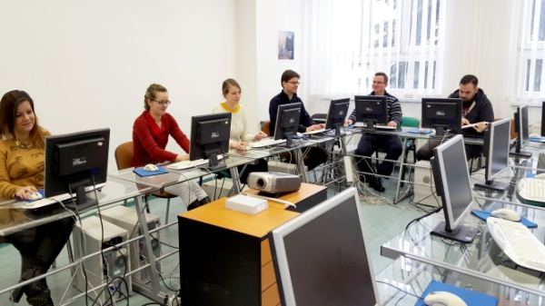
At present, industrial enterprises in Slovakia do not have enough qualified specialists. Study program wants to bring into the labour market highly skilled graduates, both for professional and managerial positions and thus increase awareness about Slovakia, not simply as a cheap labour. Investment planning in industrial enterprise has a multidisciplinary character because it combines knowledge from a technical sciences (e.g. construction, mechanical engineering, power engineering, etc.) and social sciences (e.g. economics, law).
Study program IPPP is accredited at the Institute of Management of Slovak University of Technology (STU) in Bratislava. Thus was underlined its interdisciplinary and integrative dimension, which concerns to education and research.
To this study program is preparing a Master's degree study program which will directly build on the Bachelor's degree. Currently is also accredited a PhD study program Sectoral and Branch Economies, which may be studied externally.
During the studies, students have the opportunity to participate in exchanges within the ERASMUS programme at various European universities. The study program also includes the practical training and excursions abroad.
Bachelor's degree Graduate
The Graduate of the study program is an expert with the independent decision-making and analytical thinking. He/she is able to deal with partial problems of industrial companies, in particular concerning to the vocational management, technical, economic, informational, legal and other issues of business processes. The Graduate can analyse risk in investment planning and decision making because he/she obtains the knowledge from the management of technical, technological and production process and logistics. After completion of the first degree of study the Graduate will be prepared for the study on the second level (Master's degree) or ready for immediate entrance into practice.
The Graduate of the study program finds application mainly in industrial sectors including: construction, automotive and other mechanical engineering industries, power engineering industry, etc. After entering into practice he/she will find its application as a member of the creative team, its leader or individual responsible employee in the field of planning, financial management and evaluation of investments. Also in the function of lower and middle management, which focuses from strategies and operational planning to the daily routine especially in industrial companies, in the state administration but also in the educational system and so on.
What we offer?
• quality, fair and friendly environment enabling good communication between students, Study Department, teachers and management of the Institute of Management of STU,
• corporate culture based on mutual respect, trust and respect in relation teacher - student,
• high professional level of teachers and experts from domestic and foreign practice,
• interdisciplinary approach based on co-operation with individual faculties and competent departments of STU,
• possibilities for studying for students who are physically disadvantaged, which we consider for beneficial for the formation of high quality human relations.
Contact: Institute of Management of STU, Vazovova 5, 812 43 Bratislava 1, www.um.stuba.sk
Study department: mob.: 0918 669 138, e-mail: katarina.matuskova@stuba.sk

