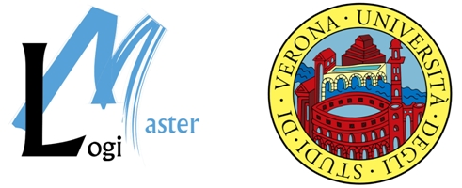

Registration form

“e-Fulfilment State-of-the-Art” Seminar”
Friday, 24 June – University of Verona, Polo Zanotto (aula magna),
Viale Universita', Verona, Italy

ATTENDANCE IS FREE!

Mr/Mrs/Ms

First Name

Family Name

Company

Job Title

Address

Postcode & City

Country

Phone

Fax

E-mail

Please confirm your attendance, sending this form to:

Foreign participants: (by fax or email)  Ms. Kelly Merinas, e-Thematic Project Assistant,  ERTICO  k.merinas@mail.ertico.com; Fax +32 (0)2 400 0701 | Italian participants: (by email)  Ms. Marilena Quintarelli, Secretary LogiMaster  Università di Verona,  logi.master@univr.it

PLEASE SEND YOUR REGISTRATION FORM BY FRIDAY 10 JUNE

The official language at the seminar is English.
Translation services will be available. English-Italian, Italian-English

For more information please contact:
ERTICO - ITS Europe

Ms Mariana Andrade
Avenue Louise 326
B-1050 Brussels, Belgium
Tel. +32 (0) 2 400 07 82
Fax +32 (0) 2 400 07 01
m.andrade@mail.ertico.com

