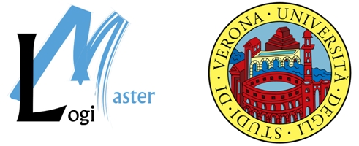

The e-Thematic Project, in collaboration with University of Verona’s LogiMaster programme, is pleased to invite you to the

“e-Fulfilment State-of-the-Art” Seminar”
Friday, 24 June – University of Verona, Polo Zanotto (aula magna),
Viale Universita', Verona, Italy

The objective of this European Commission-funded seminar is to present the results of the e-Thematic project and to learn from industry leaders about their e-Fulfilment processes (configurations, integration of software on other running applications, websites, etc.). The third in a series of successful seminars, the event is a perfect opportunity to:
- Network – meet other experts from European companies and organisations within the field of e-Logistics and e-Fulfilment
- Learn – about market developments and best practices in the area of e-Fulfilment
- Exchange – information related to your business and development activities

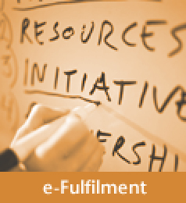  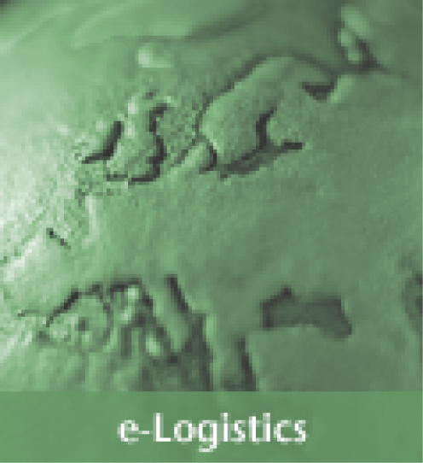     | e-Fulfilment  The area of e-Fulfilment includes the following logistics activities: customer service, order processing, finished goods inventory management, outbound transportation and sales forecasting. In short, e-Fulfilment relates to all the demand- linked logistics activities and, as such, is an important component of supply chain management. While applications for all the operational activities of logistics are already well developed, the potential of e-Fulfilment applications has not been exploited. E-Fulfilment has the largest gap between user expectations and market offer when compared to other logistics activities. Outbound transport scores especially, are very low. A new range of innovative and user centred applications must to be developed.  The e-Thematic Project: a thematic network in e-fulfilment  A European Commission-supported project funded by the Information Society Directorate General  Companies are becoming increasingly aware that e-fulfilment is a crucial part of their supply chain. However, e-Fulfilment is a new area still requiring substantial research efforts. The e-Thematic project therefore aims to determine missing research strands. The long-term goal of the project is to improve supply chain management, increase the competitive position of the European industry and to support the development towards sustainable mobility.  For more information about the e-Thematic project, please visit  WWW.E-THEMATIC.ORG  W.E-THC.ORG TIC.ORG  The LogiMaster Programme  LogiMaster is a University of Verona Master’s programme in Integrated Logistics - Supply Chain Integrated Management. It represents an important collaboration between the University of Verona and the private sector to contribute to the education and professional training of young professionals.  For more information about the LogiMaster programme, please visit  WWW.LOGIMASTER.IT

e-Thematic Seminar

“e-Fulfilment State-of-the-Art”
University of Verona, Polo Zanotto (aula magna), Viale Universita', Verona, Italy – 24 June 05 - 10:00 – 17:00

ATTENDANCE IS FREE!

Draft Programme
-- Registration from 9:30 – 10:00

10:00 – 10: 15 Welcome from the Academic Authorities of the University of Verona

10:15 – 10:25 Presentation of the e-Thematic project

Karel Vanroye, Director, Buck Consultants International

10:25 – 10: 40 Keynote Speech

Wolfgang Hoefs, Scientific Officer, European Commission
(Directorate General Information Society technologies)

10:40 – 11:00 Trends and conclusions: e-fulfilment front office

Karel Vanroye, Director, Buck Consultants International

11:00 – 11:20 Trends and conclusions: e-fulfilment back office
Patrick Haex, Senior Consultant, Buck Consultants International

11:20 – 11:40 Coffee Break

11:40 – 12:05 e-Fulfilment Strategies of TNT
Jos Kuypers, Director, TNT

12:05 – 12:30 Case Study: KPN – (Speaker To Be Confirmed)

12:30 – 12:55 e-Fulfilment of DHL
Helen Harlan, B2C Development Corporate Accounts Europe, DHL

12:55 – 1:20 Case Study: DHL Customer (Speaker To Be Confirmed)

1:20 – 1:35 Conclusions

Karel Vanroye, Director, Buck Consultants International

1:30 – 2:30 Lunch Buffet (Polo Zanotto)

2:30 – 3:00 After-lunch Entertainment (aula magna)

3:00 - 4:30 - ROUNDTABLE: "The Emerging Questions on e-Fulfilment" –
Chair: Antonio Borghesi, Director, LogiMaster University of Verona

Speakers:
Britta Gammelgaard, Director of the Diploma Program in SCM,
Copenhagen Business School
Alan McKinnon, Director of the Logistics Research Centre in the School of
Management at Heriot-Watt University, Edinburgh
Fernando Delogu, Bartolini Spa
Luca Saporetti, Supply Chain Director - Arrow Southern Europe

4:30 - 5:00 Discussion and conclusions



ACCOMMODATION
Due to the Summer Opera Festival in Verona, we recommend that you make your hotel reservations as soon as possible. The Seminar venue is Polo Zanotto on Viale Universita'. The Cooperativa Albergatori Veronesi will make all reservations for Seminar participants and will look for hotels that suit your needs.
Cooperativa Albergatori Veronesi
IMPORTANT
Tel + 39 045 800 98 44
Fax + 39 045 800 9372
www.cav.vr.it
info@cav.vr.it

EVENING

EVENT

VERONA OPERA SUMMER FESTIVAL
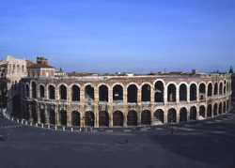
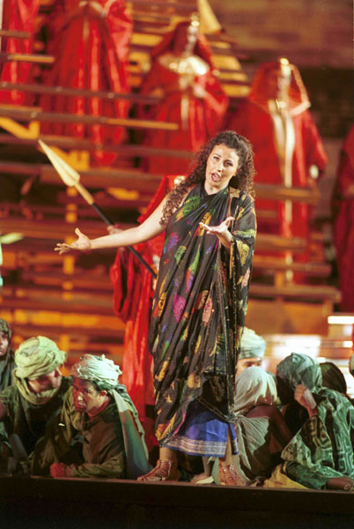
The opera season in the Arena, organized by the Arena di Verona Foundation, brings over half a million people to Verona every year. The Festival takes place at one of the greatest and most prestigious archaeological monuments in Europe, the third largest amphitheatre in Europe. Over fifteen thousand spectators enjoy the atmosphere of the amphitheatre every evening of the season: a truly cosmopolitan audience in a breathtaking setting. If you love lyrical music and wish to experience it in one of the largest lyrical theatres in the world, don’t miss the Opera Festival at the Arena of Verona.

  Agenda June - Opera Start Time at 21:15
  18 Saturday | Nabucco | Arena
  23 Thursday | Aida | Arena
  24 Friday | Nabucco | Arena
  25 Saturday | La Gioconda | Arena
  26 Sunday | Aida | Arena
  
  
  For ticket reservations and more details, please contact:
  Information and bookings by email: www.arena.it
  Information and bookings by telephone:
  +39 045 800 5151

TOURISM IN VERONA
Verona is blessed with the charm of history, a seductive weapon which the thousands of visitors to the Venetian capital every year experience and remember. The city’s rich past has left many living imprints along the streets of the city centre.
Landmarks of Verona tell great stories to everyone able to listen - churches, squares, gardens, monuments and museums are the words the town uses to compose its tales and talk about its past legacies.
For more information, visit www.tourism.verona.it/

HOW TO REACH THE LOCATION OF THE SEMINAR

How to go to Polo Zanotto: | walking | By city bus | By taxi
- from the city centre (Piazza Brà bus stop) | 10 min. | 5 min.  (bus n. 11 - 12 - 13 – 51) | 3 min.
- from the train station Porta Nuova (to the city centre) | 15-20 min. | 10 min.  (bus n. 11 - 12 - 13 - 51) | 8 min.
- from the airport "Valerio Catullo" of Verona |  | 30 min. | 20 min.
