PROGRAMME
National Conrerence ON „the Slovakia and European Research Area“

VENUE: The Slovak University of Technology in Bratislava, AULA D. Ilkoviča, Mýtna 36, Bratislava, the Slovak Republic

DATE: 27th November 2008 at 9,00 a.m.



SponSors:
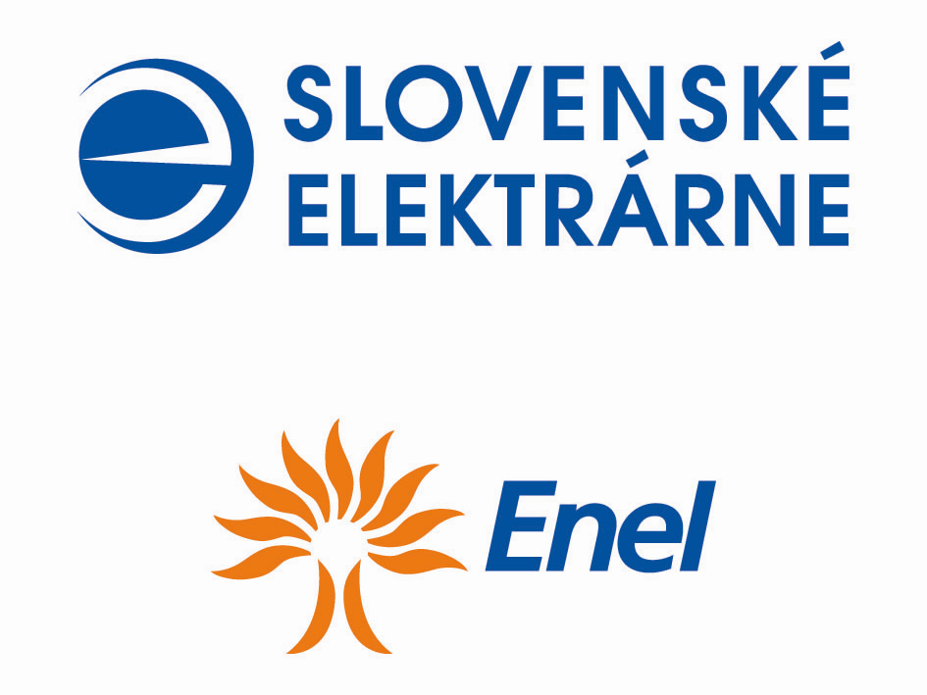







Partners:

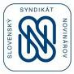

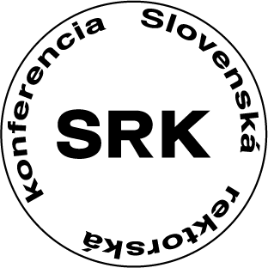

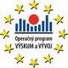
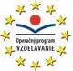
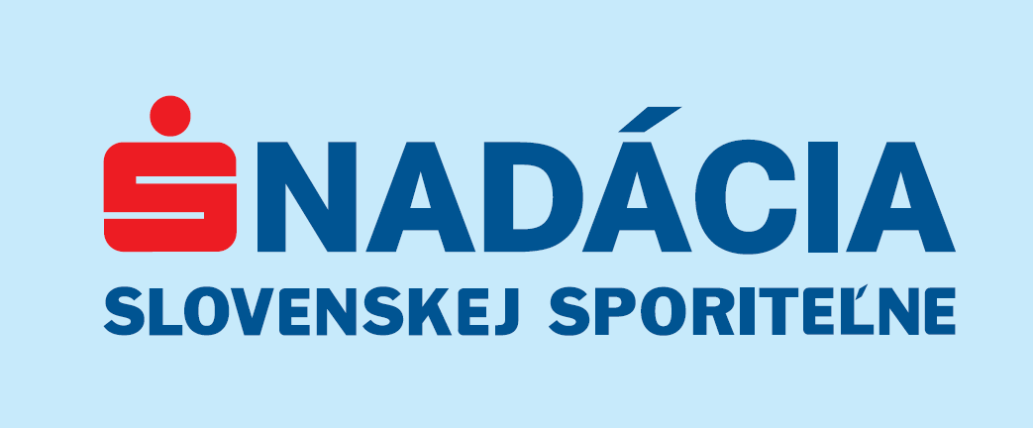


MediAL partners:



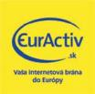



Registracion of Participants in the Conference: 8,00-9,00 a.m.

Morning Session:

Welcome by the speaker: Vladimír Báleš - Rector of the Slovak University of Technology in Bratislava
9,00-9,10 a. m.
Vladimír Báleš – Rector of the Slovak University of Technology in Bratislava

Welcome speech to the visitors, active participants and participants of the conference. Conference opening and introduction to the presentations of J. Mikolaj, Deputy Prime Minister and the Minister of Education of the Slovak Republic and D. Čaplovič,. Deputy Prime Minister of the Government of the Slovak Republic for Knowledge-Based Society, European Affairs, Human Rights and Minorities.

Introduction Part of Conference:

9,10 - 9,30 a. m.
Ján Mikolaj – Deputy Prime Minister and the Minister of Education of the Slovak Republic

Opening speech by J. Mikolaj on ,,Science and Technology Week in the Slovak Republic in 2008” and the Role of the Slovak Republic in the European Research Area”.

9,30 - 9,45 a. m.
Dušan Čaplovič – Deputy Prime Minister of the Government of the Slovak Republic for
Knowledge-Based Society, European Affairs, Human Rights and Minorities

Opening speech by D. Čaplovič focused on “How Important is to Highlight and Promote the Slovak Research and Development in Context of Knowledge Based Society Development in Europe”

conference AGENDA:

Speaker of the conference agenda

Mikuláš Šupín – Director General of Science and Technology Division of the Ministry of Education of the Slovak Republic

1st part – Experience of EU Member states with the Participation in the EU-Framework Programmes for Research, Technological Development and demonstration

09,45 - 10,05 a. m.
Johanna Ringhofer – Deputy Head of Unit, EU-Research Policy and Coordination, the Austrian Ministry of Science and Research
„Experience of Austria with the EU-Framework Programmes for RTD and the National Supporting Structures“

10,05 – 10,25 a. m.
Margit Ehardt-Schmiederer – Head of PROVISO, the Austrian Monitoring Project of the EU Framework Programmes
„The Performance of Austria in the EU Framework Programmes for RTD“

10,25 – 10,45 a. m.
Vladimír Albrecht – National Coordinator to the National Contacs Points of the EU Framework Programmes in the Czech Republic, Technology Centre of Academy of Sience of the Czech republic.
„Analytical Overview of the Czech Republic Participation in 6FP and 7FP“

Discussion: 10,45 – 11,15 a. m.

Coffe break: 11,15 -11,30 a. m.

2nd part – Experience of the Slovak R&D organiSations with the participation in European R&D programmes

11,30 - 11,45 a. m.
Vladimír Báleš – President of the Slovak Rectors´ Conference
,,Participation of the Slovak Universities in the European R&D Programmes - Current Situation, Obstacles and Perspectives“

11,45 - 12,00 a.m.
Štefan Luby – President of the Slovak Academy of Sciences
Valentin Both – Department of International cooperation of the Slovak Academy of Sciences
,,Participation of the Slovak Academy of Sciences in the European R&D Programmes - Current Situation, Obstacles, and Perspectives“

12,00 - 12,15 p. m.
Miroslav Žiak – Head of Department, SPP-Distribution, a.s. Bratislava
,,Cooperation of the SPP-Distribution, a.s. with the Slovak Universities in the Fields of Science, Research and Development“

12,15 - 12,30 p. m.
Rastislav Ňukovič – Director of Division, eustream, a.s. Bratislava
,,How to Reduce the Impact of Maintenance for the Operation of Transit Pipelines“

12,30 - 12,45 p. m.
Juraj Šitina – Direcrot of Unit's Support, Microsoft Slovakia s.r.o.
,,Benefits of the Global Commercial Companies for Innovation, Science and Research“

12,45 - 13,00 p. m.
David Gilchrist – Head of Education and Training of Human Resources, Enel, Slovenské elektrárne, a.s.
,,Designe your career“.

13,00 - 13,15 p. m.
Karla Zimanová – SAIA, n.o.
,,Barriers in Mobility of Researchers“.

Disscusion: 13,15 - 13,30 p. m.

Lunch: 13,30 - 14,30 p. m.

3rd part – Slovak Operational Programme for Research and Develepment – Slovak R&D Organisations Success Rate
14,30-14,50
Peter Mravec – Director of the Department of the OP for Research and Development,Division
of European Affairs, the Ministry of Education of the Slovak Republic
,,The Importance of Operational R&D Programme in support of R&D and Content of National Projects in 2008“
14,50 - 15,15 p. m.
Katarína Kellenbergerová – Director of the Department of the OP for Research and
Development, the Agency of the Ministry of Education of the
Slovak Republic for the Structural Funds (hereinafter „Agency“)
,,Challenges of the Agency for Demand- oriented Projects in the OP for R&D“

Disscusion: 15,15-15,45

4th part – Slovak Operational Programme for Education-Slovak R&D Organisations Success Rate

15,45 – 16,00 p. m.
Martina Šimová – Director of the Department of the OP for Education, Division of European Affairs, the Ministry of Education of the Slovak Republic
,,The Importance of the Operational Programme for Education in R&D Support and Content of National Projects in 2008”

16,00 – 16,15 p. m.
Lýdia Smilková – Director of the Department for OP for Education, the Agency of the
Ministry of Education of the Slovak Republic for the Structural Funds
,,Challenges of the Agency for Demand-oriented Projects in the OP for Education”

16,15 – 16,30 p. m.
Edmunt Škorvaga – Director of the Department of the EU Programmes and Projects, the Ministry of Health of the Slovak Republic
,,Challenges of the Ministry of Health of the Slovak Republic for Demand- oriented Projects in the OP for Education”.

Disscusion: 16,30 -16,45 p. m.

Summary: 16,45-17,00 p. m. (Speaker will make a short summary of information presented at the conference agenda and will finish the conference.)

