In the Framework of “Information Society Policy Link” Initiative

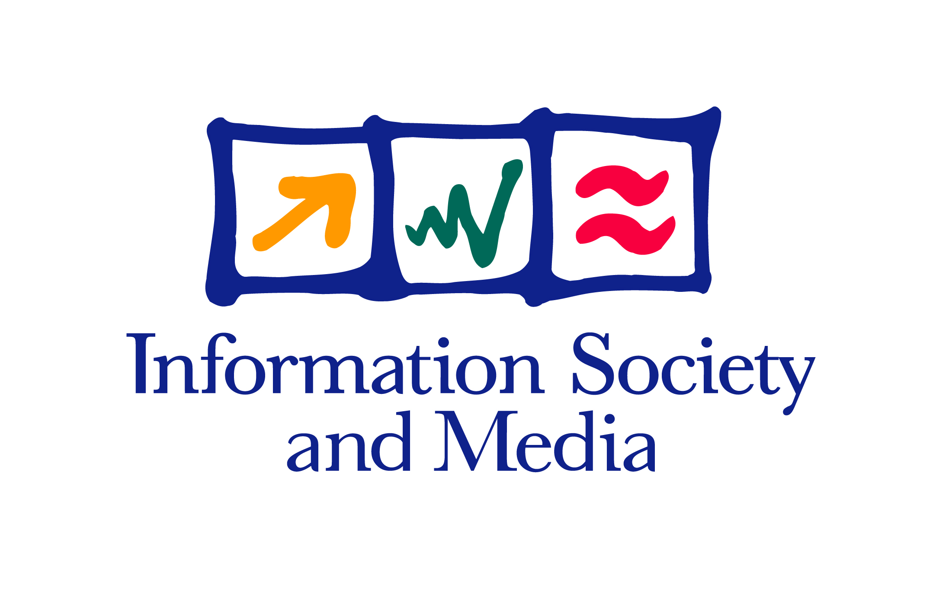

Project Policy Workshop
Theme: e-Resources for European SMEs

Hosted by UEAPME
« Union Européenne de l’Artisanat et des Petites et Moyennes Enterprises »

Venue: Brussels
UEAPME Building, Rue Jacques de Lalaing 4,

Date: Tuesday, 14 June 2005
14.00 – 18.00 hours
In the Framework of “Information Society Policy Link” Initiative
Project Policy Workshop
Theme: e-Resources for European SMEs
Background
The "Information Society Policy Link" is an initiative launched by Information Society and Media DG and addressed to EU policy makers to ensure that results from European ICT research and other programmes (eTEN, eContent) provide greater leverage, both in implementing current policies and shaping priorities for the future. Details on this initiative, its activities and Policy Workshops and its first findings (Policy Cases covering 14 EU policies are published at our website together with relevant promotions material currently print. (http://europa.eu.int/information_society/activities/policy_link/index_en.htm).

In this framework, the second IS Policy Workshop on “e-Resources for European SMEs” will take place in Brussels on 14th June 2005, from 14.00 - 18.00 hours, and will be hosted by UEAPME who are kindly supporting the event.

The main objectives of the workshop are to:
- Provide information to participants on current EU policy on these issues
- Present recent relevant results of RTD and Deployment IS projects
- Propose and discuss policy recommendations

With a view to produce policy recommendations the workshop programme is divided in three consecutive sessions (workshops within the Policy Workshop) dedicated to the different but inter-connected aspects of the main topic at stake:
- Theme 1: Relevance of eResources for the future of European SMEs
- Theme 2: eLearning and mLearning for SMEs
- Theme 3: Free vs Paid-for Content & Services to SMEs

At the end of the workshop proposals for EU policy recommendations from each one of the sessions will be presented and discussed.

Target participants:
- Policy Makers:
- DG representatives (Entreprise and Industry, Internal Market, Justice, Liberty and Security, Education and Culture, Regional Development, Employment and Social Affairs)
- Representatives from Member States, SMEs related Administrations and Agencies
- European SMEs (via their associations)
- Professional Associations and Practitioners (legal and financial auditors, accountinants, consulting firms etc.)
- ICT Companies (SMEs and Multinationals)
- Public and private Content Providers
- Other Interested Groups:
- Universities – Business & Marketing Departments
- EC Project Consortia focusing on services to SMEs
Scope:
SMEs needs
European Small and Medium Enterprises in general and, in particular, companies of industrial nature which have relatively high environmental and/or health risks associated with their activities e.g. in sectors of Automotive, Construction, Textile, Tourism, urgently need tailored business services to support them in mastering the challenging requirements for operating effectively and safely their ongoing businesses.
The driving force is the need to conform fully to the complex legal and social requirements in the fields of Environment, Health, Safety and Quality (EHS-Q) and to reduce the work overload of the key personnel. SMEs are continuously facing these increasing requirements, without having the personnel and financial resources to cope efficiently with such tasks. However, not to comply with these requirements means an uncontrolled risk for the SME and for its key personnel.
SMEs in Europe should therefore be provided with tailored business services and innovative tools – notably web based and easily accessible, with the goal to strengthen their competitive advantage at an affordable price. For this purpose they should have access to an integrated quality management system (incorporating all aspects of Environment, Health and Safety and Quality, EHS-Q), which is suited to their industry sector and size of operation. Such tools should respect all fundamental principles of security in internet, in form of digital certificates (privacy, confidentiality, integrity, authenticity and non-repudiation) and trust seals (standard approach of compliance to principles).
In addition SMEs will need company-specific "Roadmaps", which serve as integrated quality management (IQM) implementation and maintenance guidelines in the fields of EHS-Q related process implementation, Training Programmes and Certification.
Information Society and Media DG has funded several projects and initiative both in IST RTD programme and eTEN and eContent. A typical project funded by eTEN programme is PROMIS: Process Oriented integrated quality Management Internet Services for SMEs: www.promis-eu.com, presently at deployment phase, who are the initiator of this workshop.
Other INFSO funded similar funded projects are: BSOLE (eTEN) - www.bsole.com, GUIDE (eContent) – www.grant-guide.com, EASYTRADE (IST-FP5) – www.xportplus.net, ETTEC (eContent) - www.ettecproject.net.
Expected benefits
Substantial socio-economic benefits can be expected from projects and initiatives making easier the business for SME's through supporting mechanisms dealing with Environment, Health and Safety issues and legal constraints in particular. The most important ones can are summarised below:
- Better protection of the European SMEs in the field of Environment, Health and Safety
- Higher standard of environmental protection and reduction of risks
- Reduction of the work overload of the SME's key personnel
- Promotion of a new consulting profession
- High quality services to help SMEs to comply with the legal regulations and therefore become competitive and successful in the international marketplace.

Objective of the workshop:
This IS Policy Workshop represents an attempt to address the aforementioned need for SMEs by examining the nature of the impediments SMEs face in dealing with administrative and legal information with a view to becoming more competitive, presenting innovative solutions emanating from Information Society RTD and deployment projects, exploring the perceptions of European and National/regional policy makers and legislators, and in particular what SMEs really need.
By bringing together Policy Makers from several DGs (Entreprise and Industry, Internal market, Justice, Liberty and Security, Regional Development, Employment and Social Affairs) and European Ministries, Researchers and Practitioners from the sectors involved, projects results are disseminated and we give the opportunity to industry – in particular SMEs and research representatives to speak up their concerns and to address their recommendations for policy making.
The idea is to have short presentations of specific projects results summarizing their policy recommendations, followed by full discussions with the representatives from the DGs and the policy makers.

What is an IS Policy Workshop?
In the framework of the Information Society Policy Link initiative it is foreseen to organise a series of Policy Workshops i.e. working events/meetings etc. on a particular policy theme where project results from selected Policy Cases will be presented and discussed among INFSO units, Policy DGs concerned/interested, and also Project Consortia that have produced the results, with a view to better exploiting these results in support of EU policy priorities.

Themes
IS Policy Workshops’ themes may be related to policy DG priorities, specific topics, results from IS projects or clusters of projects, and finally policy initiatives of different DGs. Proposals for organising new Policy Workshops may be made to the Information Society Policy Link at any time by INFSO units (e.g. Info days, IST Event) and concerned policy DGs (eg Special events eg Green Week or Ministerial conferences) and - preferably, by Information Society project consortia as part of their dissemination of results activities. All partners in Policy Interfaces will be co-operating in the organisation of such events.
The idea of Policy Workshops resulted from the networking event held within the IST 2004 in The Hague on 16.11.2004, with participation from 6 Policy DGs, 25 project consortia and several INFSO units (see web page of the initiative). After the Networking IST Event 2004 several project consortia involved in IS projects presenting a particular interest for this exercise have submitted proposals for the organization of policy workshops.

Content
Policy Workshops may concern one or more related IS projects (cluster of projects/accompanying measures etc.) and one or several policy DGs. The workshops are expected to be half-day meetings and gather from 50 to 100 people mainly from EC services (Parliaments and Member States administrations), project consortia representatives and other stakeholders. Most of the time they will be organised by concerned project consortia under the aegis of the IS Policy Link initiative.
Additional promotions and coordination initiatives of the same nature will be launched in 2005 addressed specifically to EP and national Parliaments as well as Member States national/regional administrations.

A first indicative list of Policy Workshops has been drawn at the initiative of project consortia after the IST Networking Event last November.

In the Framework of "Information Society Policy Link" Initiative
Project Policy Workshop

"e-Resources for European SMEs"

14 June 2005, UEAPME Building, Brussels

Provisional Programme, 14 June 2005

Time | Items
13:00–14:00 | Registration and Welcome
14:00–14:15 | Setting the scene – Scope and objectives of the workshop  - Mr. Vassilios Laopodis, Information Society and Media DG, Unit C.2: Strategy for ICT Research & Development  [The “Information Society Policy Link” Initiative]
14.15-14.30 | - Opening and Welcome: Mr. Hans-Werner MÜLLER, UEAPME
14:30–15.30 | Theme 1: Relevance of eResources for the future of European SMEs
- Rep. from DG ENTR (ICT/SMEs policy) – tba
- Mrs Caterina Rehm-Berbenni - PROMIS Project
- Mr Aureo DIAZ-CARRASCO - EASYTRADE project
- Ms Cristina MARTINEZ GONZALEZ, DG INFSO Unit: Enterprise Networking
15.30-16.15 | Theme 2: eLearning for SMEs
eLearning for SMEs
- Mr. Oude WOLBERS - ETTEC project
- Mr. Pier Giacomo SOLA - BSOLE project
- Mr. Luca POLIZZI, (VIP DG EAC project intervenient)

eLearning EU Policy
- Mr. Peter BAUR, DG EAC
- Rep from INFSO Unit: Learning; Cultural Heritage (tba)
16.15-16.30 | Break
16.30–17.15 | Theme 3: Free vs. Paid-for Content & Services to SMEs
Free Content & Services to SMEs
- Ing. F. Benedetti, INAIL, Italy (tba)

Paid-for Content & Services to SMEs
- Mr R. BEHNISCH, Weka Verlag, PROMIS Partner
- Mr Erwin SEINEN - GUIDE project

Internal Market Policy considerations
- Mr. Tom DIDERICH; DG MARKT
 | Break
17.15–18.00 | Discussions on policy orientations/recommendations
18.00 | Close of the workshop

