Announcement of Fellowships for Young Researcher

at INESC Porto

VENUS, POCTI/ESE/47883/2002

INESC Porto is a large well-known private non-profit Research and Technological Development institute in Portugal and the European Union. We are announcing an open position for a young researcher to work at the research facilities of INESC Porto at Porto, Portugal financed by the European Union (FEDER) and the Portuguese Government Programmes (QCA III).
Information about INESC Porto Research Units may be found at http://www.inescporto.pt
OBJECTIVE
The researcher will be integrated in the Power Systems Unit of INESC Porto. The work program consists in the identification and development of methodologies for the evaluation of the economic value of distributed resources.

GRANT
The researcher will benefit from a grant with the monthly allowance of EURO 745,00. This amount is compatible with general living expenses in Porto, Portugal (grant values at research institutions in Portugal are fixed by the Government). Additionally, grantees will be placed under the basic health insurance protection of INESC Porto.
All traveling and subsistence expenses are the researcher’s responsibility. INESC Porto may allow, at its own discretion, in the end and for good-performing researchers, a bonus to help in supporting these expenses.
The contract will be made according to Portuguese legislation (Law no. 40/2004, August 18) and INESC Porto Fellowship Regulation.

DURATION AND BEGINNING
- Duration: 1 year (renewable) starting from 1st November 2004
- Application Period: 2004-09-22 to 2004-10-20

REQUIRED PROFILE
INESC Porto seeks candidates of excellence. A candidate must have a degree in Electrical Engineering, Computers or Economics, or similar and be familiar with
- Algorithm Graph Theory and MatLab
Preference will be given to candidates with higher degrees such as MSc. and PhD. and with knowledge and working experience on the following areas:
- Distributed resources, related impact in the network and Electric Market
Also, candidates willing to enroll in Master or Doctoral programmes at a later stage will be welcome. Preference will be given to candidates able to speak and write in English. Ability in Portuguese is a plus. Ability in Spanish, Italian and French is also welcome.

INFORMATIONS

To ask for details in relation to the scientific work, please send email to Profª Maria Teresa Ponce Leão:

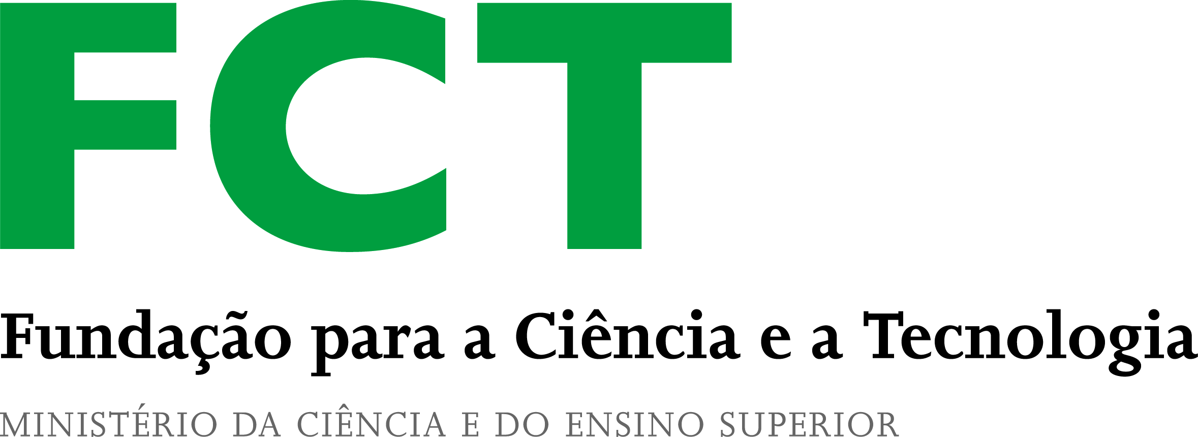
mleao@inescporto.pt
Financiamento FCT/POCTI
União Europeia
FEDER

SUBMISSION OF APPLICATION
Please send Resume (CV) and copy of diploma(s) to Mrs. Margarida Gonçalves (email: msg@inescporto.pt or FAX +351.22.2058692)
and indicate REF BI-BL/061/2004/VENUS-USE


Governo da República Portuguesa

